https://premium.wpmudev.org/blog/wordpress-theme-customizer-guide/:
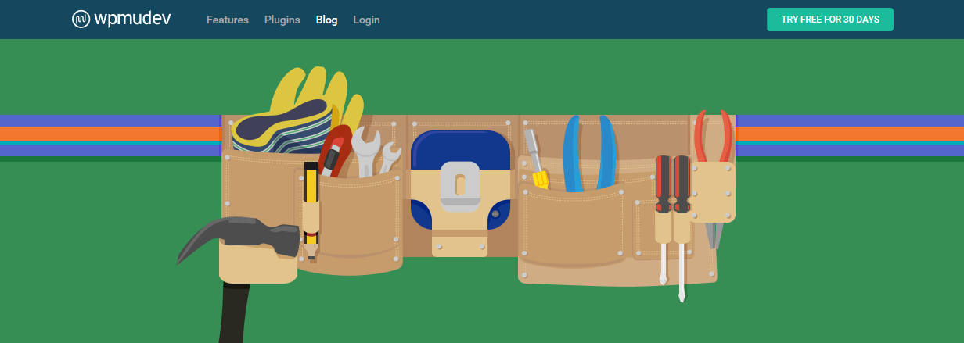
The Complete Guide to the WordPress Theme Customizer (wpmudev.org)
 | ordPress 4.7 was released with a ton of great new features (which you can check out here), including some user
experience and user interface upgrades to the theme Customizer.
In case you’re hearing about the Customizer for the first time, it’s a feature in the WordPress admin (go to Appearance > Customize) that allows users to tweak theme settings using a WYSIWYG interface and customize a theme’s colors, fonts, text, and pretty much anything else you want to change.
In this post, I’ll walk you through how the Customizer can be used in themes to create a better user experience and all the new awesomeness that WordPress 4.7 has introduced.
Contents
An Introduction to the Theme Customizer 2
Developing for the Theme Customizer 2
First Steps 2
Laying the Foundation 4
Sections, Settings and Controls 5
Creating a Section 5
Creating a Setting 5
Creating a Control 6

An Introduction to the Theme Customizer
The theme Customizer was first introduced in WordPress 3.4 and allows you to live preview changes you make to your theme. You can play around all you like without modifying your live site. And when you’ve made your changes, simply click Save and everything is applied instantly.

The WordPress theme Customizer in action.
As developers, we have access to core functionality such as the editing of the site title or header image, and we can also build custom controls for anything we’d like through the Theme Customizations API.

Developing for the Theme Customizer
There are three areas of interest when coding for the customizer. You’ll need to create the controls for the customizer, the CSS and/or logic that implements the settings in the theme and – optionally – the live preview functionality that provides a better user experience.

First Steps
Before we begin, let’s create an environment we can work in. For this tutorial let’s create a brand new, very simple theme. In fact, it won’t even qualify as a proper theme, I’ll just be using a simple index.php file to create a landing page.
My initial theme for this Customizer project.
You can download the starter theme I’m using or follow along with the code on Github to make it yourself.
If you visit the Customizer in the WordPress admin, you can already control the site title, description and additional CSS (the final one being a new feature in 4.7) of your website. This is because by default the Customizer displays changes by refreshing the whole page. We’ll make this a lot smoother a bit later but for now this will do.
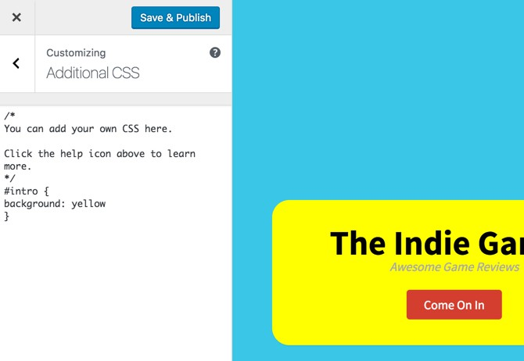Adding additional CSS in the theme Customizer

Laying the Foundation
Let’s begin by laying the groundwork for our customization efforts. I’ll create a customizer.php file and make sure to require it in the functions.php file.
- include('customizer.php');
functions-include.php hosted with ❤ by GitHub view raw

The Customizer file will begin with a hooked action that contains all our sections, settings and controls.
- add_action( 'customize_register', 'cd_customizer_settings' );
- function cd_customizer_settings( $wp_customize ) {

- }
customizer-basics.php hosted with ❤ by GitHub view raw

Sections, Settings and Controls
Sections represent the navigation within the Customizer. You should already see four of them: Site Identity, Menus, Static Front Page and Additional CSS. By defining a section we can create a new entry within the navigation and fill it up with controls.
Controls are the visual elements – the user interface – that allow us to manipulate settings. These may be input fields, text areas, color selectors and other types of controls that serve to create a better user experience.
Settings represent the data that we want our theme to accept and use. We create controls to allow users to manipulate settings easily.

Creating a Section
To add a new section we’ll use the $wp_customize->add_section() method. It takes two arguments: a section identifier and an array of additional options like the visible section title and its position within the section list.
- $wp_customize->add_section( 'cd_colors' , array(
- 'title' => 'Colors',
- 'priority' => 30,
- ) );
add-section.php hosted with ❤ by GitHub view raw

Don’t forget that the code above and any other code that creates sections, controls or settings should be placed in the cd_customizer_settings() function.
Our section is now registered, but it won’t show up until we add a control to it.

Creating a Setting
Settings inform WordPress that our theme will be using a value that can be modified by the user. They are added using the $wp_customize->add_setting() method that takes two parameters: the identifier for the setting and an array of options that contain information such as the default value.
- $wp_customize->add_section( 'cd_colors' , array(
- 'title' => 'Colors',
- 'priority' => 30,
- ) );
add-section.php hosted with ❤ by GitHub view raw

The transport actually defaults to refresh but I’ve added it since we’ll be modifying it later on. Refresh means that when the setting is modified, WordPress should refresh the view. More sophisticated Customizer implementations allow for live previews that only modify the affected element as opposed to the whole page.

Creating a Control
Controls tie settings to user input. They are added with $wp_customize->add_control() method. Argument-wise this method is a bit more complex than the previous ones.
If the first argument is a control object then only one argument is required, an instance of the object. The object will likely have its own additional arguments.
The first argument can also be an identifier, in which case a second argument of options is required.
In our case we’ll be using the WP_Customize_Color_Control class to create a color selector element.
- $wp_customize->add_control( new WP_Customize_Color_Control( $wp_customize, 'background_color', array(
- 'label' => 'Background Color',
- 'section' => 'cd_colors',
- 'settings' => 'background_color',
- ) ) );
create-control.php hosted with ❤ by GitHub view raw

The first parameter of this object should be the $wp_customize object itself, the second should be the controls id. I tend to make this the same as the setting it controls. The third array contains some options like the label, the id of the section it will be placed in and the id of the setting it controls.
We now have a complete setting-control pair which will show up in our new section. It doesn’t do anything just yet, but the setting is there and its value is actually changing.
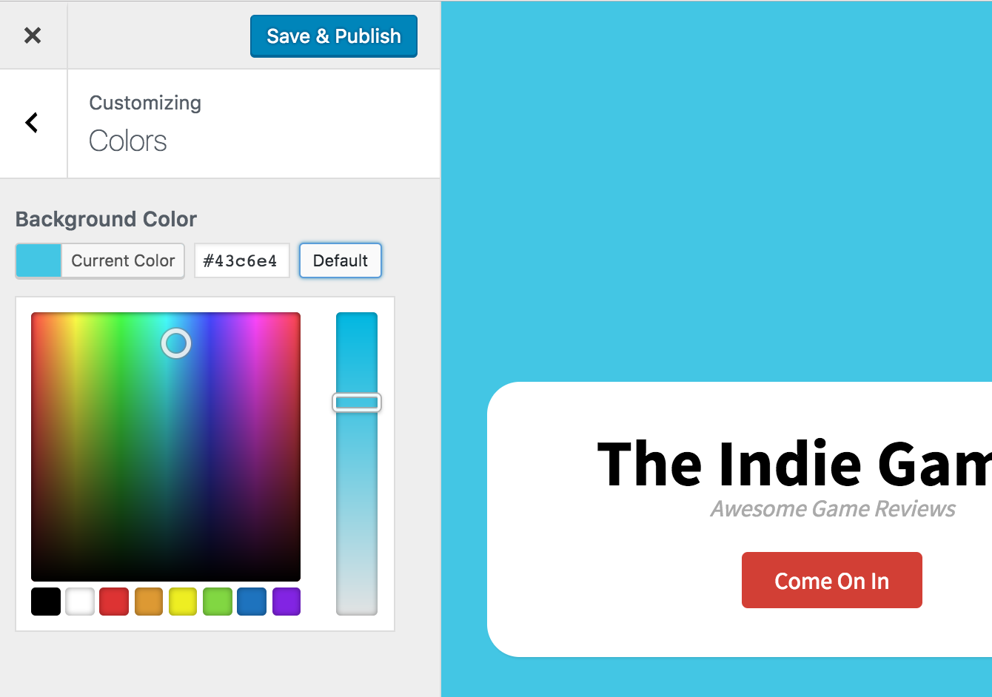The color settings in the Customizer.

Generating The CSS
To make this actually work we’ll need to apply the value of the setting to our theme. In this case, we want to make sure that the body always has the background color value as our new setting.
- add_action( 'wp_head', 'cd_customizer_css');
- function cd_customizer_css()
- {
- ?>
- <style type="text/css">
- 'settings' => 'background_color',
- ) ) );
custom-css.php hosted with ❤ by GitHub view raw

